Project Proposal

Team Name: Green Team
Dominic Tippabattuni, Ovidiu Mura

Project Name:
Graphical representation of Pushdown Automata

Context
In automata theory, a pushdown automaton (PDA) is an abstract finite state machine with extra memory in the form of a stack. PDA definition can represent any formal language.

Project Scope
The purpose of the project is to give a good understanding of how the PDA works. In this project
- Few PDA definitions are predefined with the corresponding formal language as their labels.
- The state transition diagram is represented graphically by using PDA definition. Also, the computation process of the PDA is shown graphically for user specified input strings.
- The non-determinism of the PDA will be handled by considering the transitions to set of states for every input symbol.
- Acceptance criteria:
- All the symbols in the input string must be consumed
- The set of states should include a final state of the PDA
- The stack should only contain the initial stack symbol
The project scope does not include the ability for the user to define a new language using graphical interface.

Project Iterations
Iteration 1:
Representing the definition and displaying the PDA for the language { a^n.b^n| n>0}
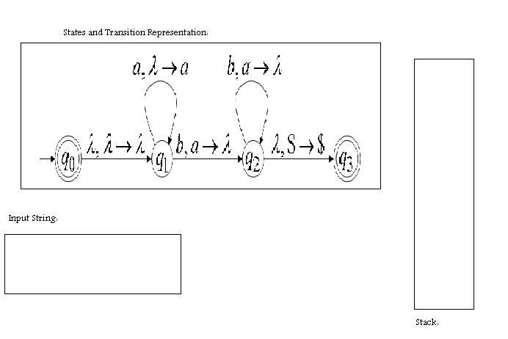
Iteration 2:
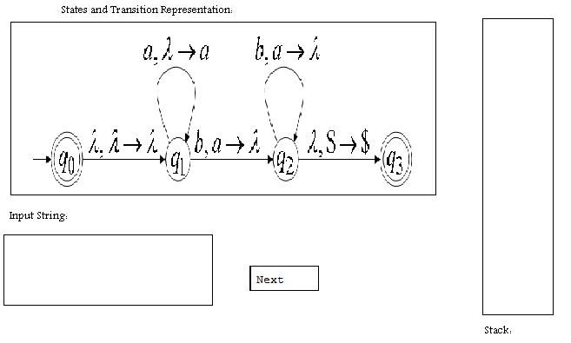
Showing how the PDA works for a fixed string using next button
aabb

Iteration 3:
Making the reset button work and allowing the user to enter the input string

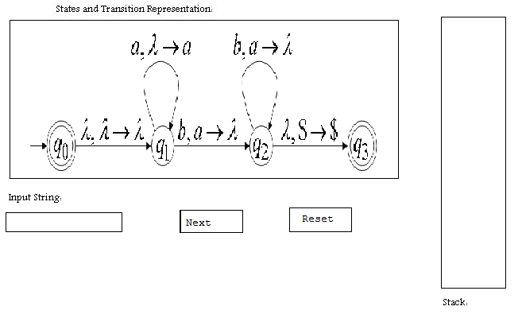

Iteration 4:
Adding choice of languages
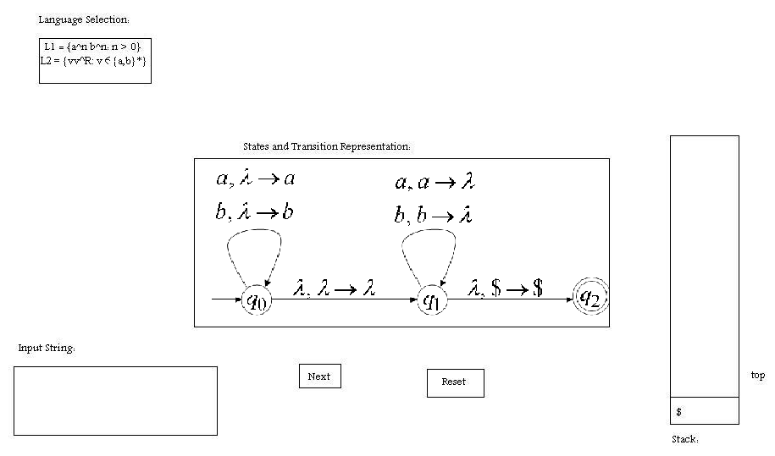
User Stories:
Typical sequence of steps:

- Setup the environment as per the instructions in the Monticello version.
- Select a formal language from the selection menu to view the state transition diagram of the language
- Input a string and run the PDA by clicking the next button repeated.
- View the final report
- Press the reset button to set the environment to the initial state.

